**Garfield’s Proof of Pythagoras’ Theorem**

Draw a right triangle ABC, with side lengths a, b and c.

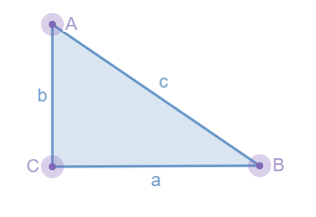

Draw a congruent triangle ADE as shown below. CD is a straight line.

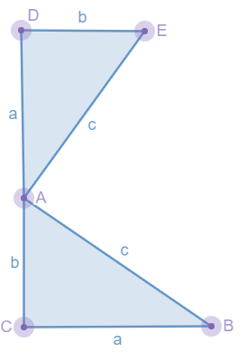

1. What does ‘congruent’ mean?

Draw a line segment EB.

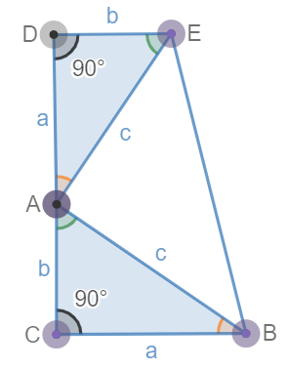

1. What do the angles in a triangle sum to?
2. What is the sum of angles CAB and CBA?
3. What is angle EAB? Explain how you know.
4. Write an expression for the area of triangle ACB.
5. Write an expression for the area of triangle ADE.
6. Write an expression for the area of triangle EAB.
7. Use your answer to parts 5), 6) and 7) to write an expression for the area of shape DEBC.
8. What is the name of shape DEBC?
9. Write down the formula to find the area of shape DEBC.
10. Use your answer to part 10) to find an expression for the area of shape DEBC.
11. Using your answers to parts 8) and 11), prove Pythagoras’ theorem.