**Homework 6**

Name__________________________

1) Estimate the number of wheels in Scotland. State any assumptions you make.

2) In January 2022, Christian deposits an amount into a savings account. He makes no other transactions.

In January 2023, Christian has £530.25 in his account. His bank account pays an effective annual rate of 5%.

How much did Christian deposit?

£_____________

3) Which has the greater volume:

A sphere of radius 3 metres;

A cylinder with a capacity of 100,000 litres?

4) You are given data and asked to produce summary statistics. Below is a histogram of the data.

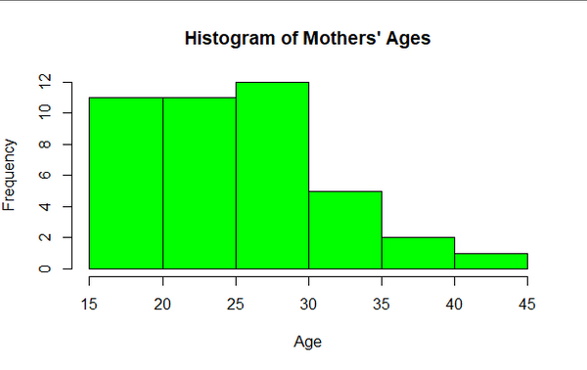

Which of the following would be appropriate statistics to give?

Choose all that apply:

1. Mean
2. Median
3. Standard Deviation
4. Interquartile range

5) You are given data and asked to produce summary statistics. Below is a histogram of the data.

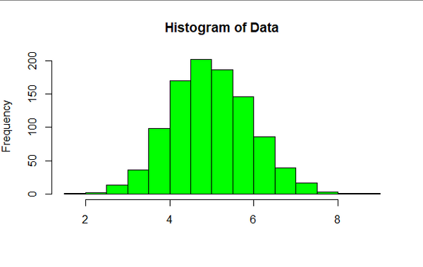

Which of the following would be appropriate statistics to give?

Choose all that apply:

1. Mean
2. Median
3. Standard Deviation
4. Interquartile range
5. Frequency

6) You are given a set of data about students' favourite flavours of ice-cream. Students could either choose "Vanilla", "Chocolate" or "Strawberry." You are asked to illustrate the data on a suitable graph.

Which of the following would be appropriate graphs:

Choose all that apply:

1. Stem and Leaf Diagram
2. Pie Chart
3. Bar Chart
4. Box Plot
5. Histogram
6. Scatter plot

7) Rosie needs to test whether the rivets produced by the factory's machine are the correct size. Rosie measures 50 rivets at random and produces a spreadsheet of her data.

To what would "population" refer to in this situation?

1. The 50 rivets Rosie measured
2. All the rivets produced by the machine
3. The employees of the factory
4. The contents of the spreadsheet

8) A T-shirt costs £150. Every day its price is reduced by 5%. Sketch a graph showing how the price of the T-shirt changes over time.

Key:

1. Consider types of wheel, use population of Scotland to consider number of cars. This question is deliberately vague- look for novel approaches.

2. 505

3. Sphere

4. B, D

5. C, A

6. B, C

7. B

8. Exponential decay