**Homework 4**

Name__________________________

1. A house appreciates in value by 5% per year. In 2010 the house was worth £250,000. Find its value in 2015, give your answer to 3 significant figures.

£_______________

2) In an experiment, 20 participants are asked to complete a memory test. The mean score on the test is 18, with a standard deviation of 6.2.

After completing the test, the participants are given some training on techniques for improving their short term memory. The participants are then given a second memory test. The mean score on the second test was 17, with a standard deviation of 2.7.

Make two valid comparisons between the test scores before and after the training.

3) Estimate the number of eggs an average Scot will eat in their lifetimes. State any assumptions you make.

4) Estimate how long it would take to walk to the moon. State any assumptions you make.

5) Quentin paid £5985 in income tax in 2022. That was a 5% increase on the previous year. How much income tax did he pay in 2021?

£_____________

6) Below is a table for income tax in Scotland.

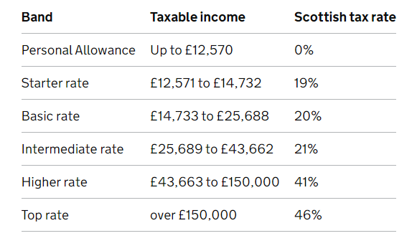

Calculate the income tax owed for a salary of £35,500.

£__________________

7) Bobby loves ice tea. Bobby loves hot tea. Bobby does not like lukewarm tea.

Sketch a graph showing Bobby's enjoyment of a cup of tea versus the tea's temperature.

8) A cylindrical container is filled with water. Sketch a graph showing how the height of the water changes over time.

Key:

1. 319000

2. 22000

3. Life expectancy, eggs per week (or day etc.)

4. Distance, speed.

5. 5700

6. 4661.90

7. Quadratic

8. Linear