**Homework 3**

Name__________________________

1) An engineer measures the energy generated in (kWh) by a wind turbine over 24 hours. The results are:

5, 5, 5.5, 6, 6.5, 7, 8, 8, 8.5, 9, 9, 9.5, 10, 10, 10.5, 10.5, 10.75, 11, 13, 13, 14, 14.5, 15, 18.

Produce a 5-figure summary for this data, and sketch a boxplot.

2) A house appreciates in value by 3% per year. In 2010 the house was worth £125,000. Find its value in 2025, give your answer to 3 significant figures.

£_______________

3) In an experiment, 20 participants are asked to complete a memory test. The mean score on the test is 12, with a standard deviation of 4.2.

After completing the test, the participants are given some training on techniques for improving their short-term memory. The participants are then given a second memory test. The mean score on the second test was 17, with a standard deviation of 2.7.

Make two valid comparisons between the test scores before and after the training.

4) Amy asks a random sample of people in her town how much they earn per year. Her data is below:

Salary (1000 £) 17, 19.5, 23, 25, 28, 30, 45, 55, 85.5

a) Calculate the median salary.

£_____________

b)

Calculate the interquartile range.

£_____________

c) Peter asks a random sample of people in his town how much they earn per year. The median salary was £31k, with an interquartile range of £25k.

Make two valid comparisons between the salaries of Amy and Peter's town.

5) Below is a precedence table for hosting an event.

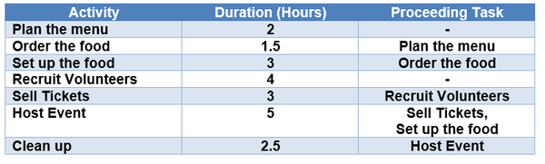

Display this in a diagram.

What is the shortest amount of time the whole project can be completed in?

_____________ hours.

6) Kevin is paid £4523 in income tax in 2022. That was a 12% increase on the previous year. How much income tax did he pay in 2021?

£__________________

7) Put the following shapes in order of volume, from lowest to highest:

A sphere with radius 4cm.

A cylinder with a radius of 4cm, and a length of 3cm.

A cone with radius of 4cm, and a length of 10cm.

A cuboid with dimensions 4cm by 3 metres by 10mm.

1. Sphere, Cylinder, Cuboid, Cone
2. Cone, Cylinder, Cone, Sphere
3. Cylinder, Cuboid, Cone, Sphere

8) Below is a table for income tax in Scotland.

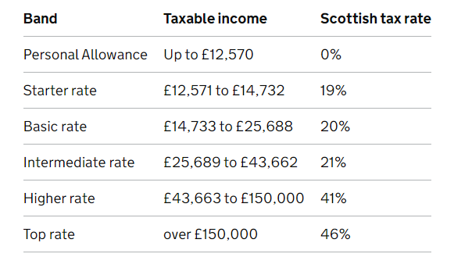

Calculate the income tax owed for a salary of £85,000.

£____________________

Key:

1.

2. 195000

3.

4a. 28000

4b. 22000

4c.

5. 14.5

6. 4038.39

7. C

8. 23329.67