**Homework 2**

Name__________________________

1) A bank account pays 4.1% interest per annum. Gabby deposits £300 into her account and leaves the money for 6 years. How much is in her account after the 6 years?

£_______________

2) Below is a precedence table.

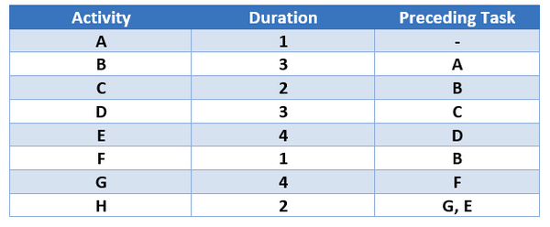

Complete the diagram:

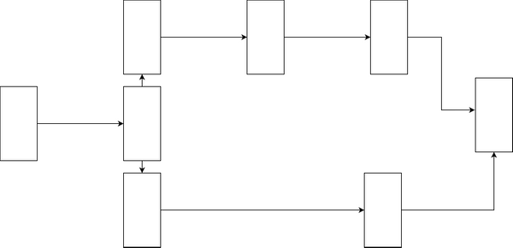

3) Below is a precedence table.

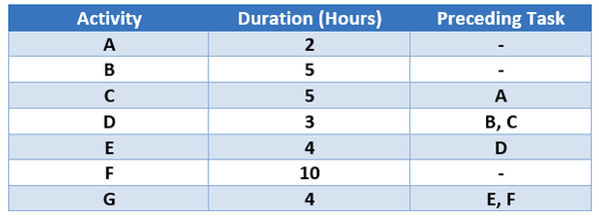

Complete the diagram:

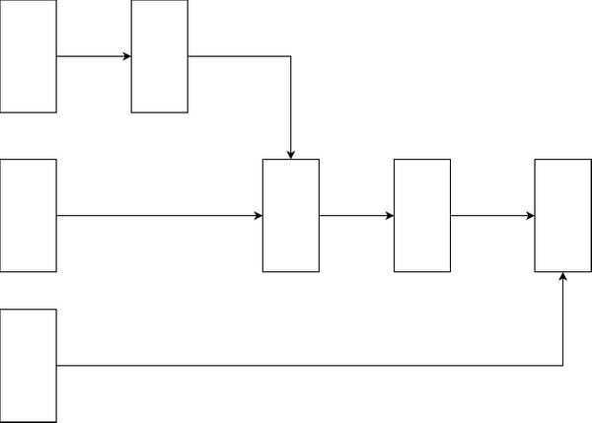

What is the shortest duration the project can be completed in?

_____________ hours.

4) This year the school musical sold 650 tickets. This was a 60% decrease from last year's sales. How many tickets were sold last year?

_____________ tickets.

5) When selling a house, the seller must pay a Land and Buildings Transaction Tax (LBTT).

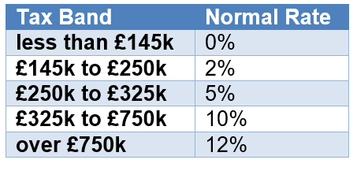

Calculate the tax owed on a building sold for £350,000.

£_____________

6) Find the volume of the solid:

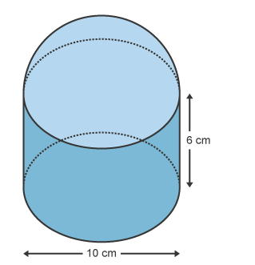

Give your answer to 2 significant figures.

_____________

7) Find the volume of the solid:

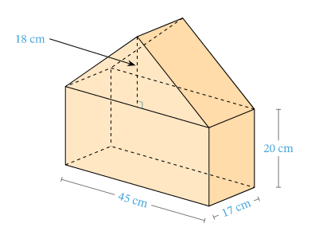

_____________

Key:

1. 381.79

2.

3. 18

4. 1625

5. 8350

6. 730

7. 22185