**Homework 1**

Name__________________________

1) Cyris has a savings account that pays 3% interest per year. She deposits £450 into her account. How much money will Cyris have in her account after 6 years, assuming the interest rate remains the same?

£_______________

2) In a simple model, the population of deer in an area increase by 0.3% per month. Initially, there are 350 deer in the area. What does the model predict the deer population will be after 4 years? Give your answer to 2 significant figures.

_____________ deer.

3) Barry deposits some money into his savings account. His account pays 2% interest per year. After 3 years, Barry's account has a balance of £13,100.61.

How much money did Barry originally deposit?

£_____________

4) Peter invested some money into a 1 year savings bond. The bond paid an effective rate of 2% per annum. After 1 year, the bond matured and was worth £1530. Calculate the amount of money that Peter invested.

£_____________

5) A newspaper article says that the number of tourists visiting the Edinburgh Festivals increased by 4% this year from last. If this year approximately 425,000 tourists visited, approximately how many visited last year?

Give your answer to 3 significant figures.

_______________

6) When selling a house, the seller must pay a Land and Buildings Transaction Tax (LBTT).

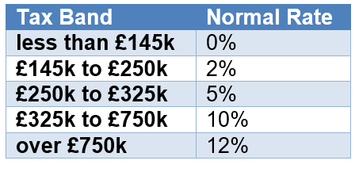

1. Calculate the tax owed on a building sold for £150,000.

£_____________

1. Calculate the tax owed on a building sold for £300,000.

£_____________

1. Calculate the tax owed on a building sold for £950,000.

£_____________

**Key:**

**1. 537.32**

**2. 400**

**3. 12345**

**4. 1500**

**5. 409000**

**6. 100**

**7. 4600**

**8. 72350**